Latent Semantic Analysis
Latent semantic indexing (LSI) is a technique that uses a statistical method called singular value decomposition (SVD) to isolate underlying latent semantic structure in the data that is partially obscured by the randomness of word choice with respect to retrieval. This method is based on the patterns of co-occurrence of words, which takes a large a matrix of term-document association data and constructs a "semantic" space wherein terms and documents that are closely associated are placed near one another (Landauer, T.K.&Dumais, S.T., 2008)
Truncated Singular Value Decomposition (SVD)
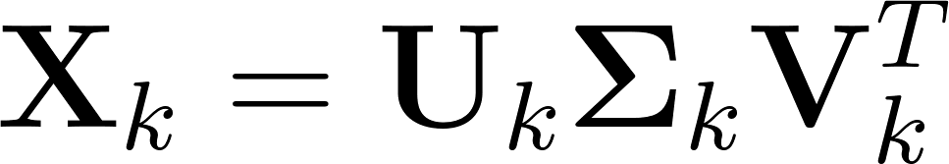

To calculate how related documents j and q are in the low-dimensional space by comparing the vectors

Typically by cosine similarity:
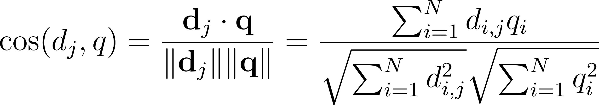

T-Distributed Stochastic Neighbour Embedding (T-SNE)

T-SNE is an unsupervised machine learning method that is used to visualize the higher dimensional data in low dimensions. T-SNE is used for designing/implementation and can bring down any number of feature space into 2-D feature space (Laurens van der Maaten&Geoffrey Hinton, 2008).

T-SNE minimizes the sum of KL divergences over all the data points using a gradient descent method.
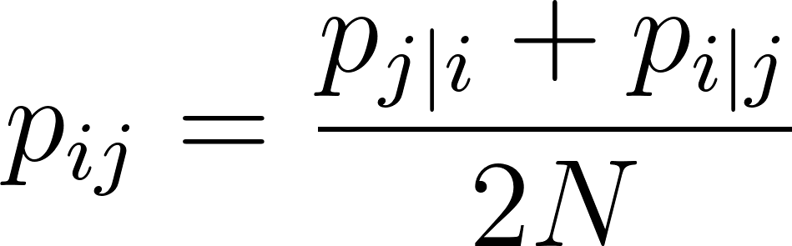
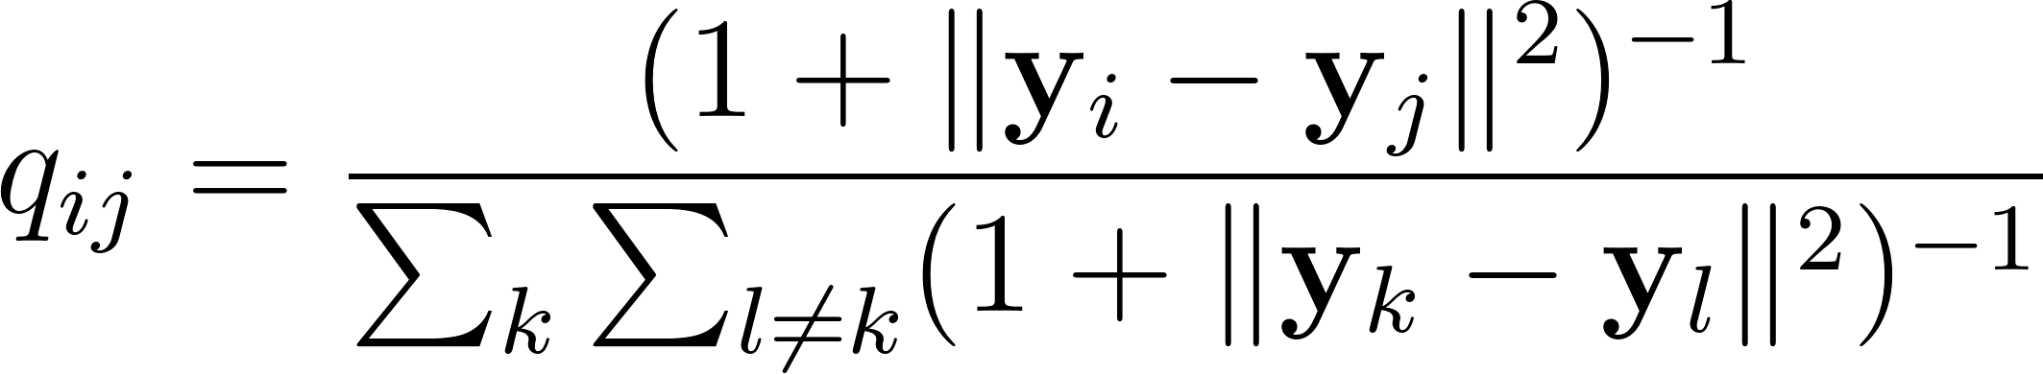
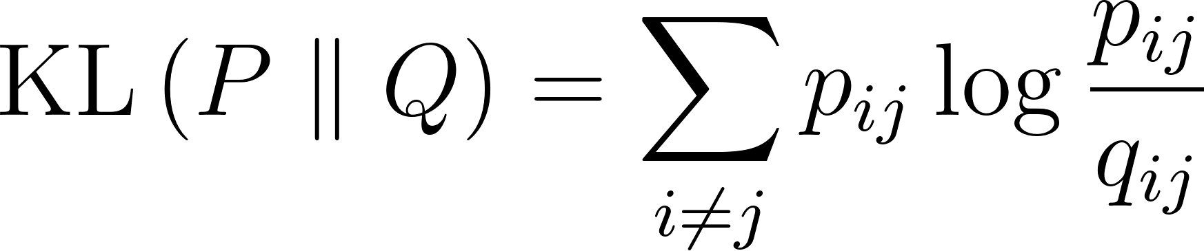

The perplexity hyperparameter is really important when we need to get the result. It generally can be considered as a smoothed number of nearest neighbors. For each point $$x_i$$, the algorithm searches for the optimal Gaussian variance $$\sigma_i$$ such that the resulting distribution $$P_i$$ has the desired perplexity (Van Der Maaten et al., 2008). Different perplexity values could lead to different outcomes, and large data sets often require larger perplexity values.(Wattenberg et al., 2016)

In the research, we choose the value 50 as the perplexity value, since we have large data sets and this value could help us better identify different topics.

UMASS coherence
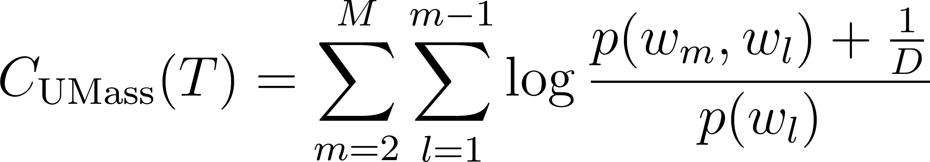
If UMASS is closer to value 0 means perfect coherence, and it fluctuates on either side of value 0 depending upon the number of topics chosen and the kind of data used to perform topic clustering. The best way to judge UMASS is to plot a curve between UMASS and different values of K (number of topics). Choose K with the value of UMASS close to 0 (Mimno et al., 2011).
For different data sets, the UMASS coherence values give us a different number of topics because the words and the number of data sets varies.

General 7 Topics
We generalized the core content topics based on the top 50 words in our 7 topics of all text from TV, magazine, newspaper, and the internet. 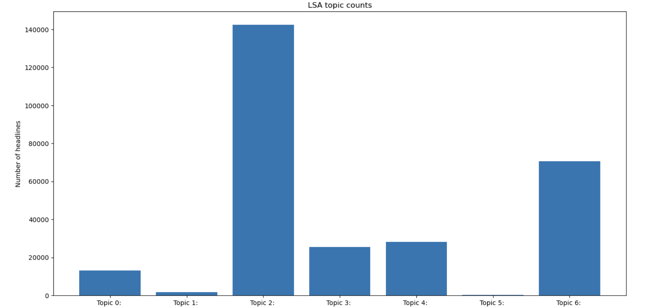

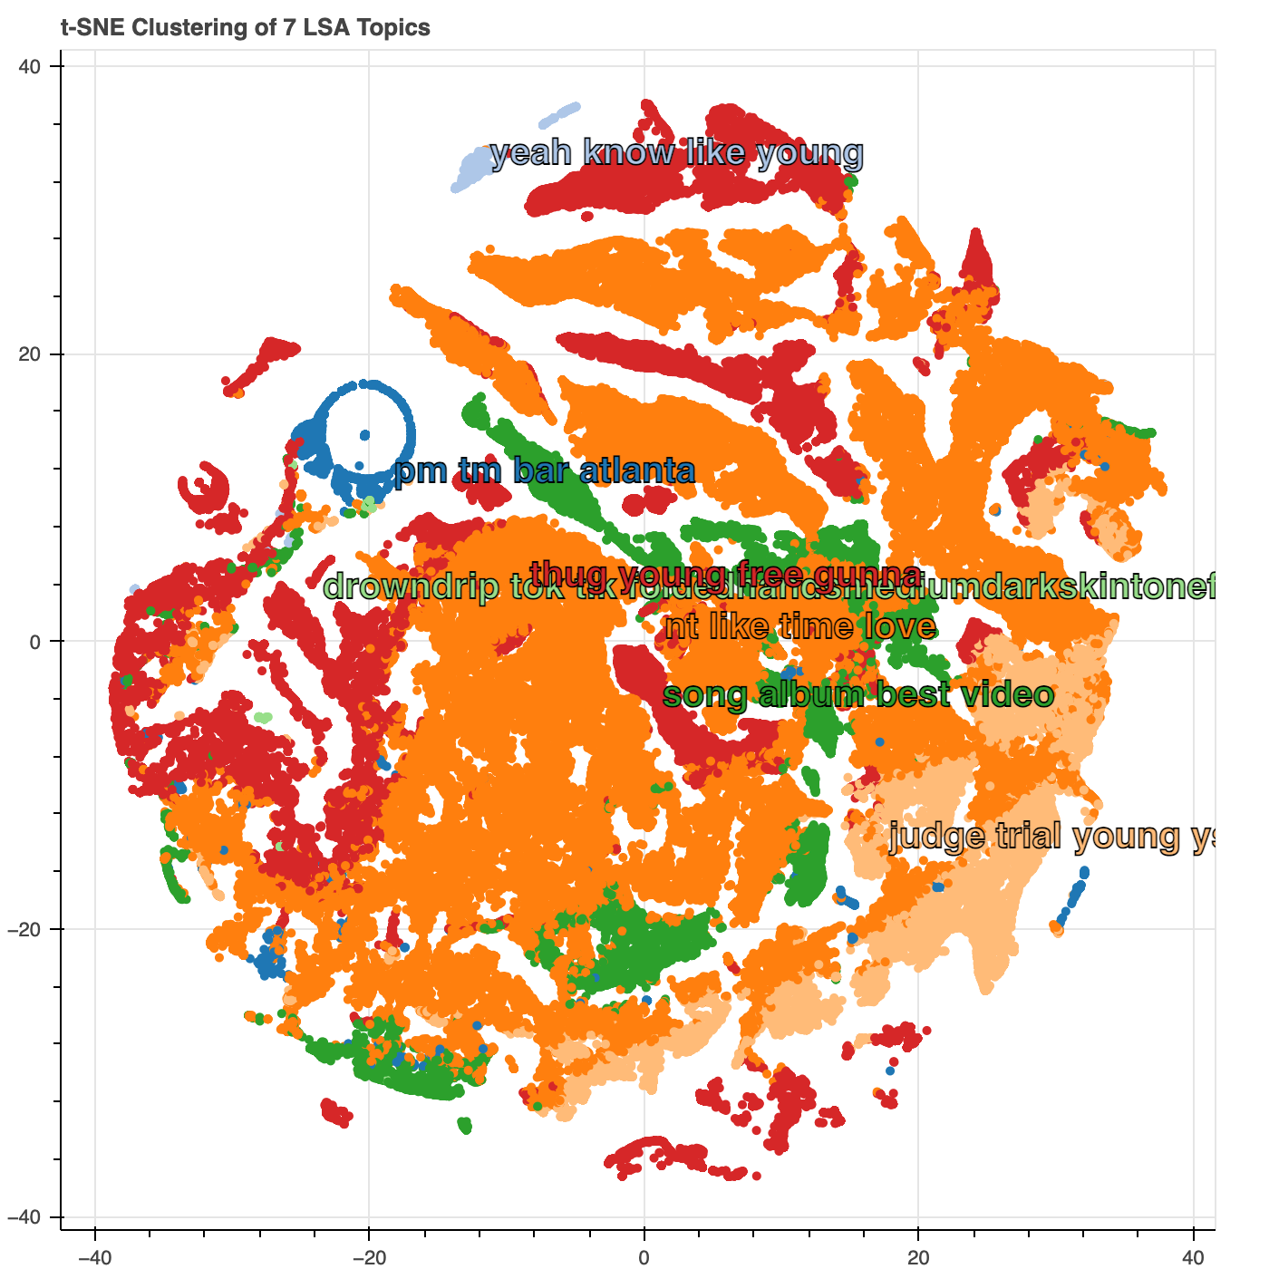

Topic 1: Live Music in Atlanta
Top Words: pm, tm, bar, atlanta, smiths, olde, masquerade, amphitheatre, theatre, buckhead, tabernacle, fox, symphony, ticket, band, etc.
The topic 1 most focuses on live music events in Atlanta, since it includes names of some local venues in Atlanta (e.g., Tabernacle, Masquerade), and related terms (e.g., ticket, band, amphitheatre)

Topic 2: Slang
Top Words: yeah, like, lil, gon, thug, gunna, fuck, bitch, woah, baby, love, play, song, message, skiyeah, etc.
The topic 2 most includes slang content, such as rap-related content (e.g., lil, gunna, thug), hype exclamations (e.g., yeah, woah, skiyeah), and profanity (e.g., fuck, bitch).

Topic 3: Trial-related Content
Top Words: love, judge, thug, gunna, case, trial, music, atlanta, court, state, rapper, beat, year, says, etc.
Topic 3 includes different types of words related to the trial of Young Thug and Gunna, like some juridical terminology (e.g., judge, case, trial) and rap-connected content (e.g., music, rapper, beat).
The number of words in this topic is the largest, suggesting that most content of all the text focuses on the discussion of the YSL trial.

Topic 4: Legal System and Judicial Process of YSL Trial
Top Words: judge, trial, ysl, thug, court, rico, gang, fulton, jury, attorney, charges, evidence, indictment, etc.
Topic 4 is a focused topic on the legal system and judicial process of the YSL trial. This includes a large number of juridical terminology (e.g., judge, trial, court, jury, attorney, charges, evidence, etc. )

Topic 5: Music
Top Words: song, album, artist, video, drake, taylor, bieber, weeknd, feat, cardi, stallion, kendrick, remix, awards, etc.
Topic 5 most focuses on music topic. It includes many musicians and artists (e.g., drake, taylor bieber, weekend, carti) and music industry terminology (e.g., song, album, remix, feat).

Topic 6: Social Media Slang and Emojis
Top Words: drowndrip, tok, tik, foldedhandsmediumdarkskintone, grimacingface, wtfwho, uzbekistan, dovedragoneagle, mistrialsmilingfacewithsmilingeyes, purpleheart
This topic includes many different emojis on social media and many emojis (😬grimacingface, 🙏🏾foldedhandsmediumdarkskintone, 💜purpleheart), social media slang (lmfao, plz, vc, coz).

Topic 7: Free Thug Support
Top Words: thug, free, gunna, ysl, slime, snitch, thugger, thugga, goat, lol, rapper, bro, facewithtearsofjoy, etc.
This topic is about the content of support for Young Thug and Gunna. The word “free” is especially highlighted, which indicates that there are a group of people who strongly support freeing Young Thug and Gunna.
The number of words in this topic is larger than 60000, suggesting that much of the content of all the text is related to this topic.

